Ch. Bhargav Ram
26)
<!DOCTYPE html>
<html>
<head>
<title>Traffic Squad</title>

<style>
body {
font-family: Arial;
background: #e3f2fd;
text-align: center;
}

h1 {
color: #0d47a1;
}

.box {
background: white;
width: 320px;
margin: 20px auto;
padding: 15px;
border-radius: 10px;
box-shadow: 0 0 8px gray;
}

h2 {
color: #1565c0;
}

li {
list-style: none;
padding: 6px;
}
</style>
</head>

<body>

<h1>Traffic Squad</h1>
<p>Penalty Collection & Management System</p>

<div class="box">
<h2>User</h2>
<ul>
<li>Register</li>
<li>Login</li>
<li>View Challan</li>
<li>View Case Filed</li>
</ul>
</div>

<div class="box">
<h2>Police</h2>
<ul>
<li>Login</li>
<li>View Rules</li>
<li>Create Case</li>
<li>Upload Proof Photo</li>
<li>Manage Traffic Reports</li>
<li>Google Map Traffic</li>
</ul>
</div>

<div class="box">
<h2>Admin</h2>
<ul>
<li>Manage Police Login</li>
<li>View Daily Report</li>
</ul>
</div>

</body>
</html>

OUTPUT:
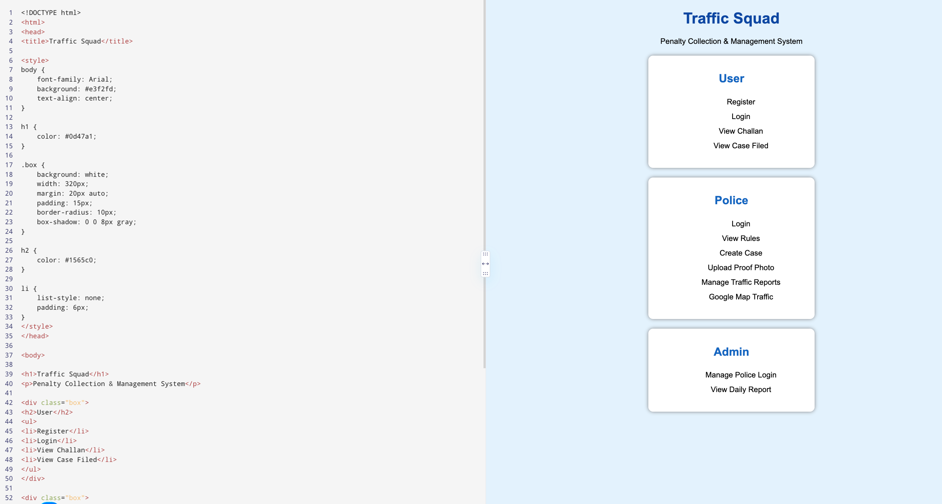

27.<!DOCTYPE html>
<html>
<head>
<title>Bus Pass Management</title>

<style>
body {
font-family: Arial;
background: #fff3e0;
text-align: center;
}

h1 {
color: #e65100;
}

.box {
background: white;
width: 330px;
margin: 20px auto;
padding: 15px;
border-radius: 10px;
box-shadow: 0 0 8px gray;
}

h2 {
color: #ef6c00;
}

li {
list-style: none;
padding: 6px;
}
</style>
</head>

<body>

<h1>Bus Pass Management System</h1>

<div class="box">
<h2>Admin</h2>
<ul>
<li>Login</li>
<li>Manage Student & Route Pass</li>
<li>Manage Conductor Login</li>
<li>Approve Bus Pass</li>
<li>Generate QR Code</li>
<li>Create Bus Details</li>
<li>Create Route Information</li>
</ul>
</div>

<div class="box">
<h2>User</h2>
<ul>
<li>Register</li>
<li>Login</li>
<li>Add Money - eWallet</li>
<li>Buy Bus eTicket</li>
<li>Apply New Bus Pass</li>
<li>Renewal Bus Pass</li>
<li>Apply Student & Route Pass</li>
<li>Get QR Code</li>
<li>Calculate Expected Time</li>
</ul>
</div>

<div class="box">
<h2>Conductor</h2>
<ul>
<li>Login</li>
<li>Scan QR</li>
<li>Verify Bus Pass ID</li>
<li>Verify Bus Ticket</li>
<li>Update Bus Location</li>
</ul>
</div>

</body>
</html>

OUTPUT:
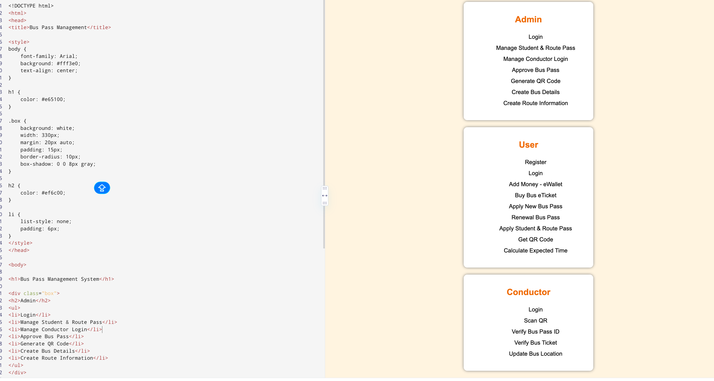

28)
<!DOCTYPE html>
<html>
<head>
<title>ArtistryHub</title>

<style>
body {
margin: 0;
font-family: Arial;
background: #f8f1e7;
color: #333;
}

header {
background: #4a2c2a;
color: white;
text-align: center;
padding: 25px;
}

nav {
background: #6d403b;
text-align: center;
padding: 12px;
}

nav a {
color: white;
text-decoration: none;
margin: 15px;
}

section {
width: 85%;
margin: 25px auto;
background: white;
padding: 25px;
border-radius: 10px;
box-shadow: 0 0 8px #bbb;
}

.gallery {
display: flex;
gap: 20px;
justify-content: center;
flex-wrap: wrap;
}

.art {
width: 200px;
background: #eee;
padding: 10px;
text-align: center;
}

.art img {
width: 100%;
height: 150px;
object-fit: cover;
}

button {
background: #4a2c2a;
color: white;
padding: 10px 20px;
border: none;
border-radius: 5px;
}
</style>
</head>

<body>

<header>
<h1>ArtistryHub</h1>
<p>Portfolio of Artist Emily Harris</p>
</header>

<nav>
<a href="#home">Home</a>
<a href="#about">About</a>
<a href="#portfolio">Portfolio</a>
<a href="#media">Media</a>
<a href="#news">News</a>
<a href="#contact">Contact</a>
</nav>

<section id="home">
<h2>Welcome</h2>
<p>Explore the beautiful artwork and creative journey of Emily Harris.</p>
</section>

<section id="about">
<h2>About the Artist</h2>
<p>
Emily Harris is a talented artist known for her creative paintings
and unique artistic style.
</p>
</section>

<section id="portfolio">
<h2>Portfolio</h2>

<div class="gallery">

<div class="art">
<img src="https://images.unsplash.com/photo-1549490349-8643362247b5">
<p>Abstract Art</p>
</div>

<div class="art">
<img src="https://images.unsplash.com/photo-1579783902614-a3fb3927b6a5">
<p>Modern Painting</p>
</div>

<div class="art">
<img src="https://images.unsplash.com/photo-1577083288073-40892c0860a4">
<p>Creative Art</p>
</div>

</div>
</section>

<section id="media">
<h2>Media Gallery</h2>
<p>Photos, videos and interviews of the artist.</p>
</section>

<section id="news">
<h2>News & Updates</h2>
<p>Upcoming exhibitions and latest projects.</p>
</section>

<section id="contact">
<h2>Contact</h2>
<p>Email: artist@example.com</p>
<button>Send Message</button>
</section>

</body>
</html>

OUTPUT:
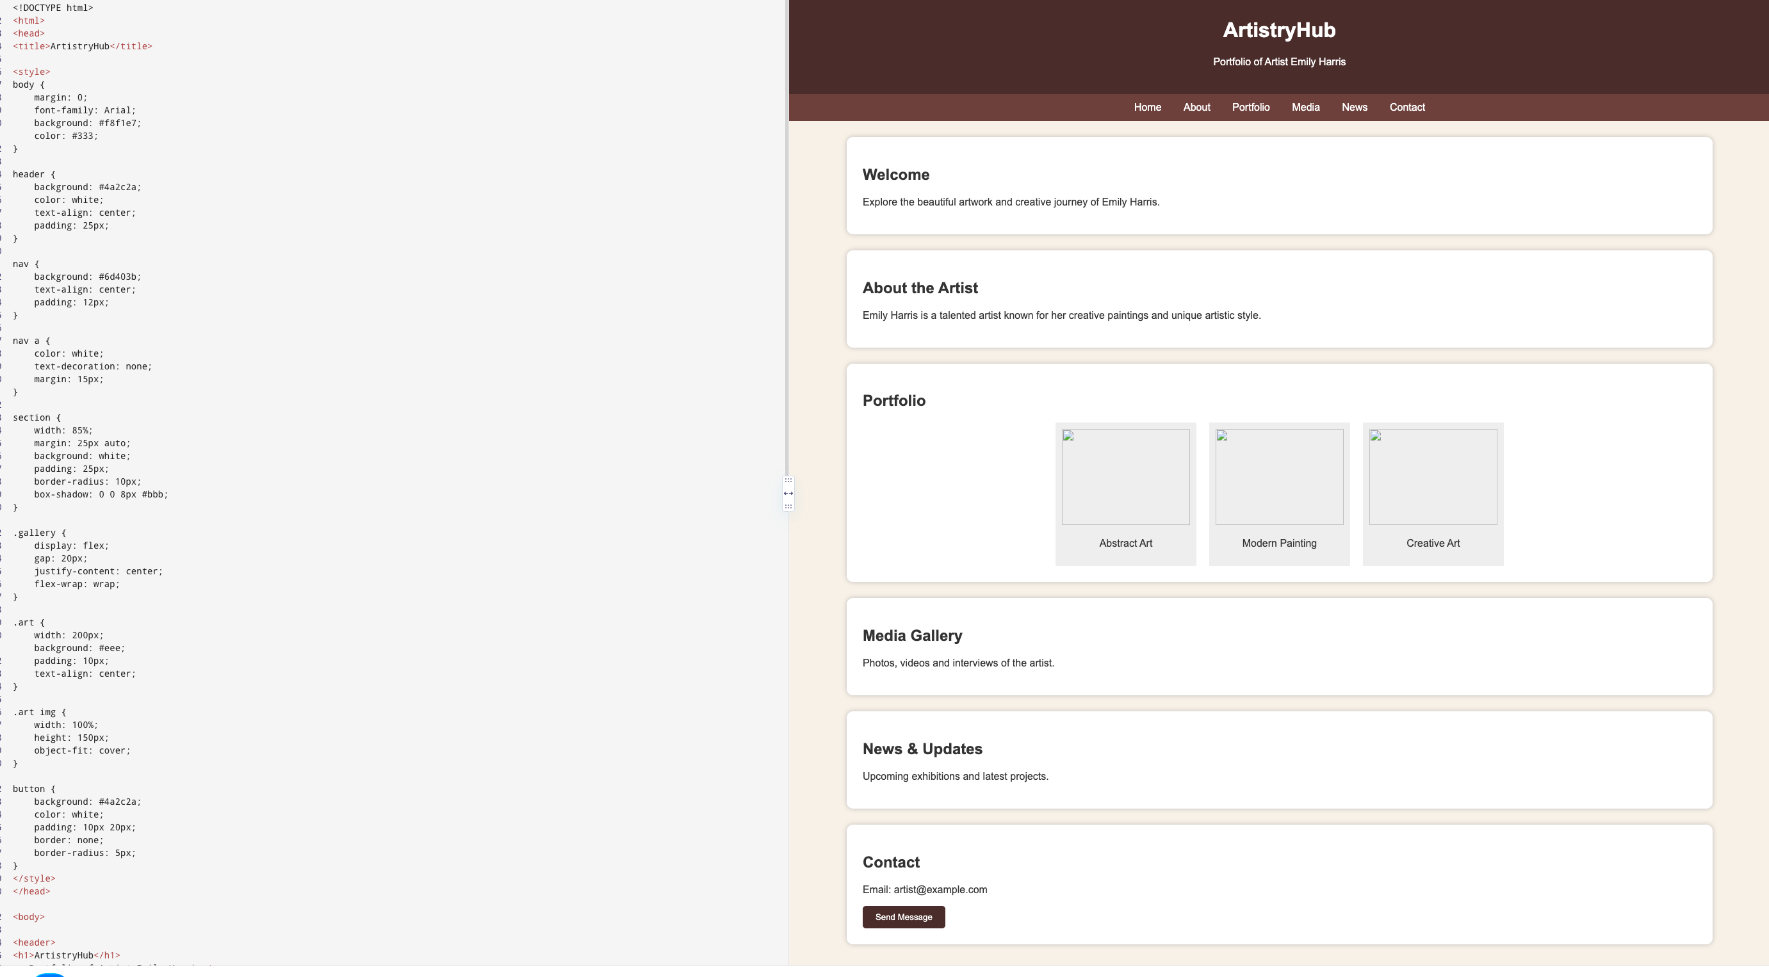

29)<!DOCTYPE html>
<html>
<head>
<title>Event Page</title>

<style>
body {
margin: 0;
font-family: Arial;
background: #f3f4f6;
text-align: center;
}

header {
background: #263238;
color: white;
padding: 30px;
}

section {
background: white;
width: 80%;
margin: 20px auto;
padding: 20px;
border-radius: 10px;
box-shadow: 0 0 8px #bbb;
}

.speakers {
display: flex;
justify-content: center;
gap: 20px;
flex-wrap: wrap;
}

.speaker {
background: #eceff1;
padding: 15px;
width: 180px;
border-radius: 8px;
}

.speaker img {
width: 100px;
height: 100px;
border-radius: 50%;
}

button {
background: #1565c0;
color: white;
border: none;
padding: 12px 25px;
border-radius: 6px;
cursor: pointer;
}
</style>
</head>

<body>

<header>
<h1>Technology Innovation Event</h1>
<p>Learn, Connect and Innovate</p>
</header>

<section>
<h2>Speakers</h2>

<div class="speakers">

<div class="speaker">
<img src="https://randomuser.me/api/portraits/men/32.jpg">
<h3>John Smith</h3>
<p>Technology Expert</p>
</div>

<div class="speaker">
<img src="https://randomuser.me/api/portraits/women/44.jpg">
<h3>Emily Davis</h3>
<p>AI Specialist</p>
</div>

</div>
</section>

<section>
<h2>Event Purpose</h2>
<p>
This event helps students and professionals learn about
new technologies and innovation.
</p>
</section>

<section>
<h2>Venue</h2>
<p>ABC Convention Hall, Hyderabad</p>
</section>

<section>
<h2>Schedule</h2>
<p>10:00 AM - Welcome</p>
<p>11:00 AM - Guest Lecture</p>
<p>01:00 PM - Lunch</p>
<p>02:00 PM - Workshop</p>
</section>

<section>
<h2>Registration</h2>
<p>Register now to participate in the event.</p>
<button onclick="alert('Registration Successful!')">
Register Now
</button>
</section>
</body>
</html>
OUTPUT:
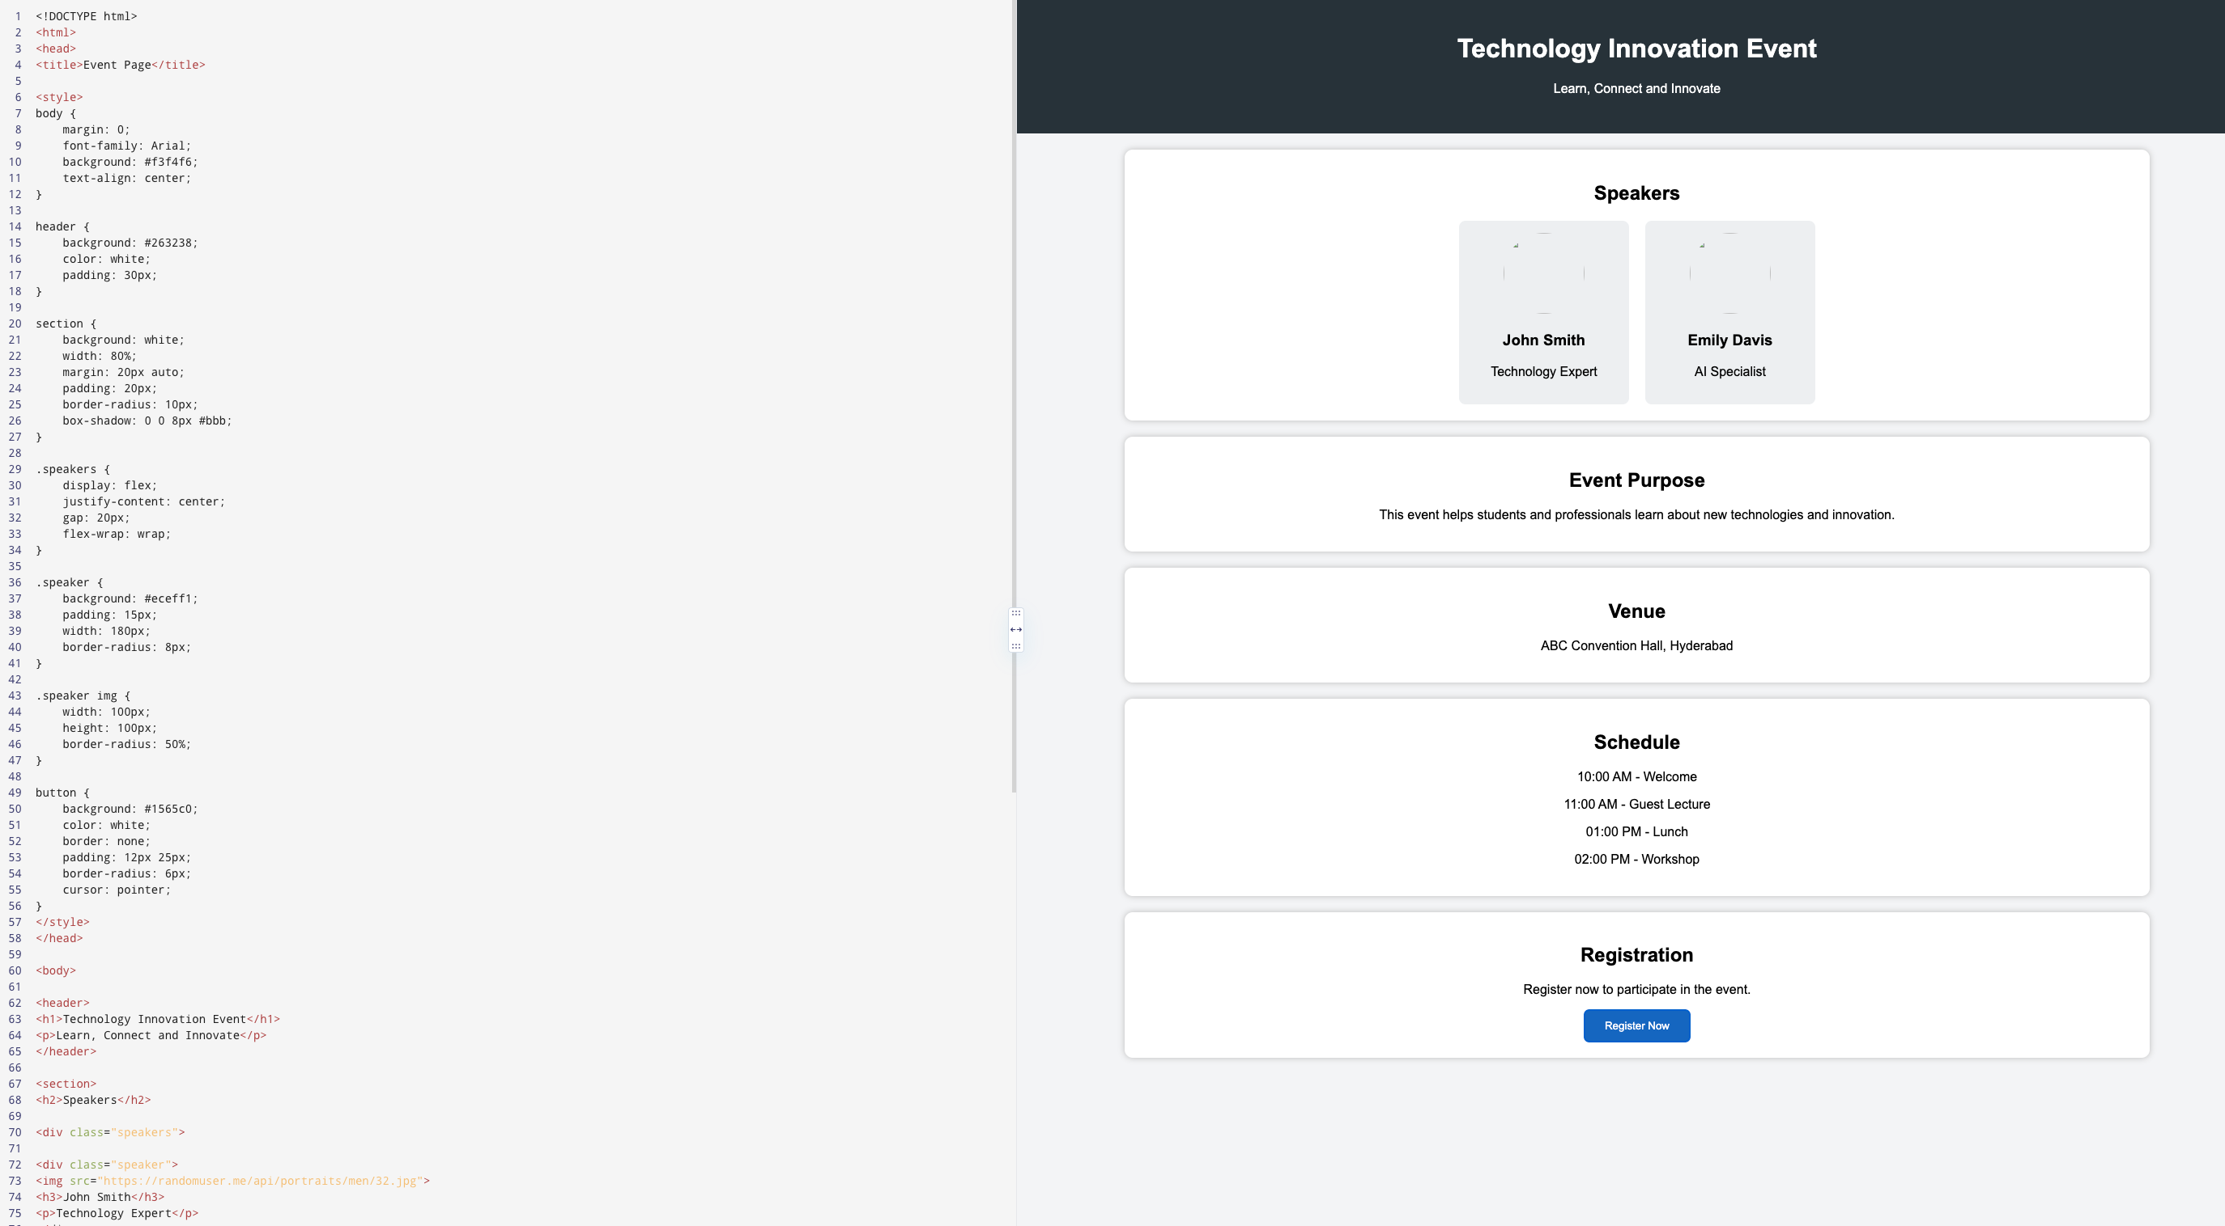

30)<!DOCTYPE html>
<html>
<head>
<title>IJSSE Journal</title>

<style>
body {
margin: 0;
font-family: Arial;
background: #f4f7fb;
}

header {
background: #12355b;
color: white;
text-align: center;
padding: 25px;
}

nav {
background: #1d5d8f;
text-align: center;
padding: 12px;
}

nav a {
color: white;
text-decoration: none;
margin: 10px;
}

section {
background: white;
width: 85%;
margin: 20px auto;
padding: 20px;
border-radius: 8px;
box-shadow: 0 0 7px #ccc;
}

h2 {
color: #12355b;
}

button {
background: #12355b;
color: white;
border: none;
padding: 10px 18px;
border-radius: 5px;
}

li {
margin: 8px;
}
</style>
</head>

<body>

<header>
<h1>International Journal of Scientific and Social Excellence</h1>
<p>IJSSE | Print ISSN: 2395-1443 | Online ISSN: 2395-1451</p>
</header>

<nav>
<a href="#home">Home</a>
<a href="#about">About</a>
<a href="#authors">Authors</a>
<a href="#reviewers">Reviewers</a>
<a href="#editors">Editors</a>
<a href="#articles">Articles</a>
<a href="#contact">Contact</a>
</nav>

<section id="home">
<h2>Home</h2>
<p>Welcome to the IJSSE academic journal website.</p>
</section>

<section id="about">
<h2>About Journal</h2>
<p>
IJSSE provides a platform for publishing scientific and
social research articles.
</p>
</section>

<section>
<h2>Publication Ethics</h2>
<p>We follow ethical standards for academic publishing.</p>
</section>

<section id="editors">
<h2>Editorial Board</h2>
<ul>
<li>Editor Registration</li>
<li>Editor Login</li>
<li>Editorial Committee</li>
<li>Editor Responsibility</li>
</ul>
</section>

<section id="reviewers">
<h2>Reviewers</h2>
<ul>
<li>Reviewer Registration</li>
<li>Reviewer Login</li>
<li>List of Reviewers</li>
</ul>
</section>

<section id="authors">
<h2>Authors</h2>
<ul>
<li>Author Registration</li>
<li>Author Login</li>
<li>List of Papers</li>
<li>Author Instructions</li>
<li>Publication Charge</li>
<li>Article Template</li>
<li>Copyright Form</li>
<li>Author Guidelines</li>
</ul>
</section>

<section id="articles">
<h2>Articles</h2>
<ul>
<li>Current Issue</li>
<li>Archive</li>
<li>Most Viewed Articles</li>
<li>Most Cited Articles</li>
<li>About to Print Articles</li>
</ul>
</section>

<section>
<h2>Call for Paper</h2>
<button>Submit Manuscript</button>
<button>Subscribe Newsletter</button>
</section>

<section id="contact">
<h2>Contact Us</h2>
<p>Email: ijsse@example.com</p>
<p>Phone: +91 9876543210</p>
</section>

</body>
</html>

OUTPUT
